
RAMAIAH
Institute of Technology
USN | 1 | M | S

(Autonomous Institute, Affiliated to VTU)
(Approved by AICTE, New Delhi & Govt. of Karnataka) Accredited by NBA & NAAC with ‘A’ Grade

SUPPLEMENTARY SEMESTER EXAMINATIONS – AUGUST 2019

Course & Branch | : | B.E.: Information Science and Engineering | Semester | : | IV
Subject | : | Design and Analysis of Algorithms | Max. Marks | : | 100
Subject Code | : | IS44/IS414 | Duration | : | 3 Hrs

Instructions to the Candidates:
- Answer one full question from each unit.

 |  | UNIT- I
1. | a) | Write the Euclid’s algorithm to find GCD of two numbers and indicate (i) a natural size metric for its inputs (ii) its basic operation (iii) whether the basic operation count can be different for inputs of the same size. | CO2 | (10)
 | b) | Algorithm Min2 (A[l..r])  if l = r return A[l]  else temp1 ← Min2 (A[l.._(l + r)/2_])  temp2 ← Min2 (A[_(l + r)/2_+1..r])  if temp1 ≤ temp2 return temp1  else return temp2  - What does this algorithm do?  - Set up a recurrence relation for the algorithm’s basic operation and solve it. | CO3 | (10)
2. | a) | Design a recursive algorithm for computing the sum of the first n cubes.  S(n) = 1³ + 2³ + ... + n³. Set up and solve a recurrence relation for the number of times the algorithm’s basic operation is executed. | CO2 | (06)
 | b) | Compare the order of growth of  - ½(n(n-1)) and n².  - Log₂n and √(n). | CO3 | (04)
 | c) | Explain the different asymptotic notations. For each of the following functions, prove that  - 200n+8 Є О(n²)  - n⁵ Є Ω(n⁴)  - 1/2n(n-1) Є ϴ(n²) | CO1 | (10)
 |  | UNIT– II
3. | a) | Write the pseudocode for selection sort algorithm. Is selection sort stable? | CO2 | (05)
 | b) | Apply Mergesort to sort the list E, X, A, M, P, L, E in alphabetical order. Draw the tree of the recursive calls made. Set up a recurrence relation for the number of key comparisons made by mergesort on best-case inputs and solve it for n = 2^{k} | CO4 | (08)
 | c) | I) Which of the three classic traversal algorithms yields a sorted list if applied to a binary search tree?  II) Traverse the following binary tree in  - pre-order ii. in-order iii. post-order.  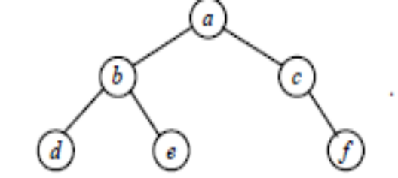  III) Analyze the efficiency of the traversal algorithms. | CO1 | (07)
4. | a) | Solve the average-case recurrence for quicksort. | CO3 | (06)
 | b) | Construct the shift table for Horspool’s algorithm for the following text and pattern and trace the algorithm, showing all steps clearly.  Text: Honesty_is_the_best_policy  Pattern: policy | CO4 | (06)
 | c) | i) Write a pseudocode for preorder traversal algorithm,for binary trees. Assuming that your algorithm is recursive, find the number of recursive calls made.  ii) Draw a binary tree with ten nodes labeled.0, 1, 2, ..., 9 in such a way that the inorder and post-order traversals of the tree yield the following lists: 9, 3, 1, 0, 4, 2, 7, 6, 8, 5 (inorder) and  9, 1, 4, 0, 3, 6, 7, 5, 8, 2 (postorder). | CO1 | (08)
 |  | UNIT- III
5. | a) | Design an algorithm for solving all pair shortest path problem. Apply the same to fond the all pair shortest paths in the below graph.  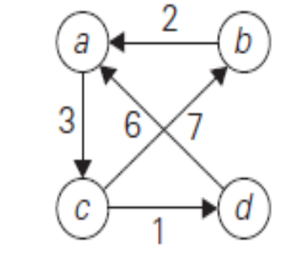 | CO2 | (10)
 | b) | Explain the concept of greedy technique for prim’s algorithm. Obtain minimum cost spanning tree for the graph below prim’s algorithm.  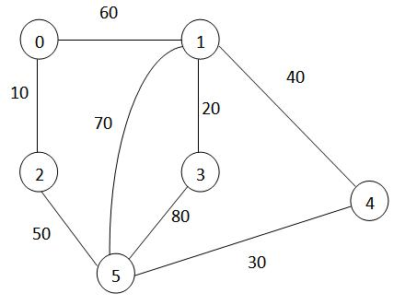 | CO1 | (10)
6. | a) | Design a bottom - up dynamic algorithm for the knapsack problem and apply it on the following instance of the knapsack_problem, with given capacity W = 5. | CO2 | (10)
  Item | Weight | Value
  1 | 2 | 12
  2 | 1 | 10
  3 | 3 | 20
  4 | 2 | 15
 | b) | Write Dijkstar’s algorithm. Apply the same to find shortest paths from vertex ‘5’ to all other vertices of the graph.  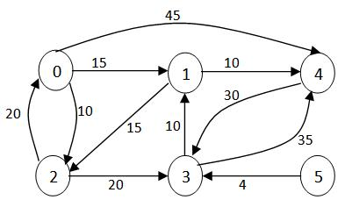 | CO2 | (10)
 |  | UNIT - IV
7. | a) | What is Josephus problem? Illustrate with an example the different methods of solving Josephus problem. Find J(9) using all the methods. | CO4 | (10)
 | b) | Define AVL tree and 2-3 tree. Construct AVL Tree and 2-3 Tree for the list 9,5,8,3,2,4,7,0,1,6. | CO1 | (10)
8. | a) | Design an algorithm for Depth First Search traversal using decrease and conquer technique. Trace the same for the following graph (starting at vertex A) showing the stack contents and also show the DFS tree.  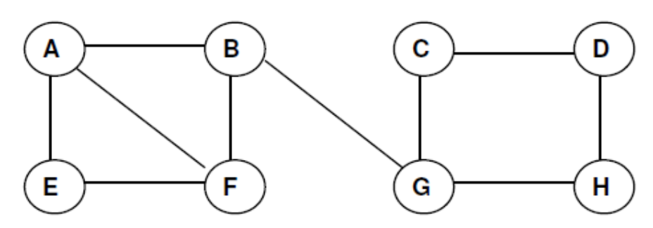 | CO2 | (10)
 | b) | Give an algorithm that works like a card player who inserts a newly dealt card into a previously dealt and ordered hand that was already put in order also give worst case analysis of this algorithm. | CO2 | (10)
 |  | UNIT- V
9. | a) | List and explain in detail about the two algorithm design techniques that are used to solve NP hard problems. | CO1 | (10)
 | b) | Apply branch and bound algorithm to solve the travelling salesman problem for the given graph.  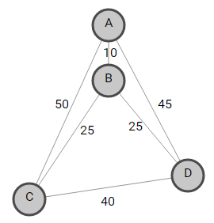 | CO4 | (10)
10. | a) | What is back tracking? Explain how is it applicable to solve N-queens problem. | CO1 | (10)
 | b) | Explain heap and its vital properties:  - Construct a heap for the list 1, 8, 6, 5, 3, 7, 4 by the bottom-up algorithm.  - Construct a heap for the list 1, 8, 6, 5, 3, 7, 4 by successive key insertions. | CO1 | (10)

****************

